**Software Modeling Questions**

If you want to plan project activities such as developing new functionalities or test cases, which of the following UML artifacts is the most useful?

1. Sequence diagrams
2. Use cases.
3. Domain model.
4. Package diagrams.

ANSWER:B

Which of the following is iterative, incremental, use case driven and architecture centric?

1. V-method.
2. UML.
3. Component Based Development.
4. RUP

ANSWER:D

What is true about UML stereotypes?

1. A stereotype is used for extending the UML language.
2. A stereotyped class must be abstract.
3. The stereotype {frozen} indicates that the UML element cannot be changed.
4. UML Profiles can be stereotyped for backward compatibility

ANSWER:A

Consider a beverage machine. If the actor is ‘customer’, and the scope is ‘machine’, what is

most likely to be found in the main scenario of the use case ‘get drink’?

- enter choice

- if drink available then show price

- put in coins

- if paid enough then deliver drink

- customer enters choice

- machine shows price

- customer puts in coins

- machine delivers drink

1. .

- enter choice

- show price

- put in coins

- deliver drink

1. .

- ...

- machine sends price to LCD display

- customer put coins in slot

- coin mechanism verifies amount and tells machine controller

- machine controller activates boiler

ANSWER: B

Consider the following situation: a company realizes projects; each project is executed by a team of employees. Which would be a suitable conceptual UML diagram.

1. 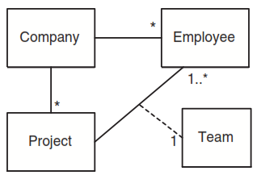.
2. 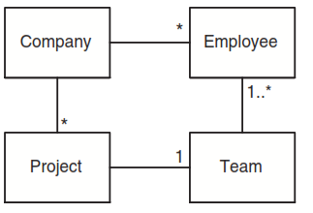.
3. 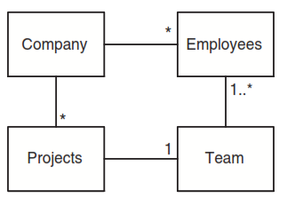.
4. 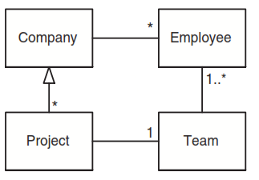.

ANSWER: B

How do you express that some persons keep animals as pets?

1. 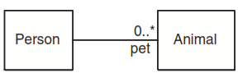.
2. . 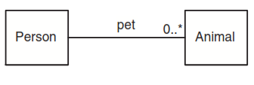.
3. 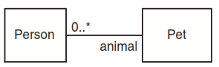.
4. 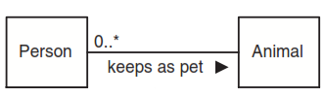.

ANSWER:A

What can UML interfaces be used for?

1. to provide concrete classes with the stereotype <<interface>>
2. to program in Java and C++, but not in C#
3. to define executable logic that can be reused in several classes
4. to specify required services for types of objects

ANSWER:D

Consider the following design.

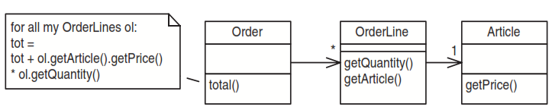

How would the introduction of a subtotal() method in OrderLine improve the design?

1. It increases the cohesion of Article.
2. It reduces the coupling of Order.
3. It reduces the cohesion of Order.
4. It increases the coupling of Article.

ANSWER:B

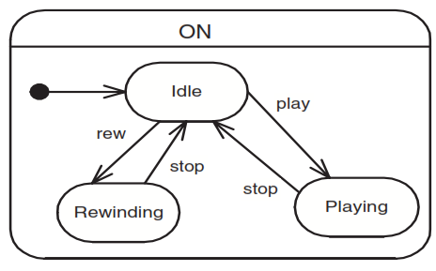What is correct about the following State Diagram?

1. ‘ON’ is a concurrent state.
2. This State Diagram is invalid because it contains no final state.
3. ‘play’, ‘stop’ and ‘rew’ are actions.
4. ‘ON’ is a superstate.

ANSWER:D

Which of these activities COULD occur simultaneously?

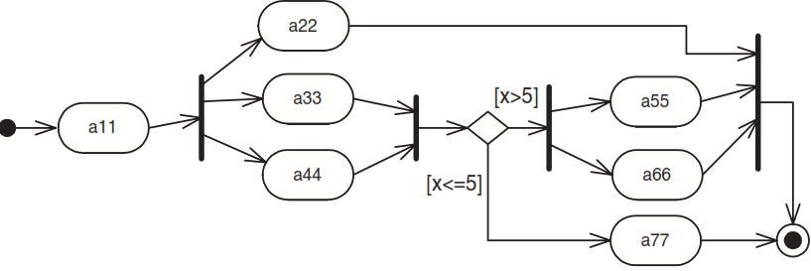

1. a44 and a66
2. a44, a33 and a22
3. a22 and a77
4. B and C

ANSWER:D

Which are valid events in a State diagram?

1. after()
2. when()
3. if ()
4. A and B

ANSWER:D

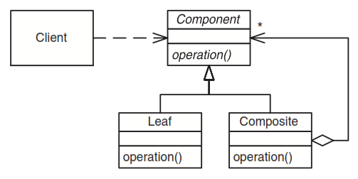This is the structure of a well-known GoF pattern; which one?

1. Component
2. Delegation
3. Polymorphism
4. Composite

ANSWER:D

Which of the following are known refactorings (according to Fowler)?

1. Protect Variations
2. Replace Inheritance with Delegation
3. Replace Delegation with Inheritance
4. B and C

ANSWER:D

If you need to show the physical relationship between software components and the hardware in the delivered system, which UML diagram can you use?

1. component diagram
2. deployment diagram
3. class diagram
4. network diagram

ANSWER:B

What is a true statement about the following packages?

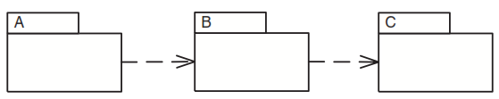

1. If package C changes, package B must be inspected for necessary changes, and if there are any, package A may have to be adapted as well.
2. If package B changes, package A and package C must be inspected for necessary changes.
3. Packages should be designed so that a change in one package does not have an effect to other packages.
4. If package C changes, package A has to be examined (as well as B), because dependencies are transitive.

ANSWER:A

Given the following diagram, which method(s) should be implemented for the Account class?

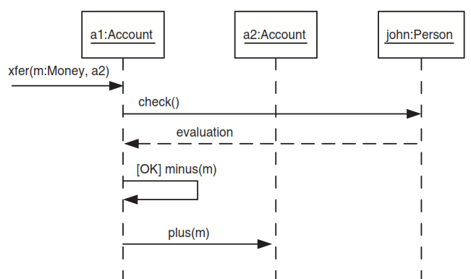

1. xfer()
2. xfer(), plus(), minus()
3. check(), plus(), minus()
4. xfer(), evaluation(), plus(), minus()

ANSWER:B

Which is true about the method doIt()?

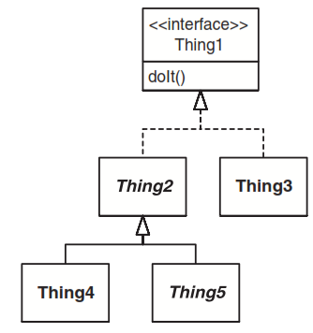

1. The method doIt() must be implemented by Thing3 and possibly also by Thing4.
2. The method doIt() must be implemented only by Thing5.
3. The method doIt() must be implemented by Thing2, Thing3, Thing4 and Thing5.
4. There is no need for any class to implement doIt(),because it is already implemented by Thing1.

ANSWER:A

What is true about a Sequence Diagram?

1. It describes the behaviour in many Use Cases.
2. It describes the behaviour in an Activity diagram
3. It describes the behaviour of a single object.
4. It describes the behaviour of several objects.

ANSWER:D

Which GRASP pattern do you use to decide who is going to handle the incoming system events?

1. Controller
2. Low coupling
3. Adapter
4. Information Expert

ANSWER:A

Which UML diagram is NOT commonly used for illustrating use cases?

1. system sequence diagram
2. activity diagram
3. use case diagram
4. collaboration diagram

ANSWER:A

Washing machines, toasters, radios, blenders are all appliances In the world of object orientation, one

would say that each one is a(an) ___________. of the *Appliance* class.

1. behaviour
2. subclass
3. superclass
4. aggregation

ANSWER:B

The property that different objects can respond to the same message in different ways is known as

___________.

1. (a) inheritance
2. (b) encapsulation
3. (c) polymorphism
4. (d) interface

ANSWER:C

___________ is the packing of data and functions into a single component.

1. Polymorphism
2. Generalization
3. Encapsulation
4. Composition

ANSWER:C

Objects hide their inner workings of their operations from the outside world and from other objects.

This is called ___________.

1. encapsulation
2. Inheritance
3. generalization
4. polymorphism

ANSWER:A

Consider the following statements related to Use Case diagrams.

(i) An extends relationship between use cases means that the base use case explicitly incorporates the

behaviour of another use case at a location specified in the base.

(ii) A Use Case model should describe all of the implementation specifics of an application.

(iii) A Use Case diagram identifies all of the actors, use cases and their relationships.

Which of the above statements is/are correct?

1. Only (i)
2. Only (ii)
3. Only(i) and (ii)
4. Only (iii)

ANSWER:D

Which type of class relationship can be described as "has a" or “part of” relationship?

1. Generalization/Specialization
2. Association
3. Composition
4. include

ANSWER:C

Complete the following incomplete sentence.

___________ is a directed relationship which is used to show that some UML element or a set of

elements requirements, needs or depends on other model elements for specification or implementation.

1. Communication
2. Multiplicity
3. Dependency
4. Inheritance

ANSWER:C

The relationship between Car and tyre in the this diagram is

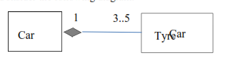

1. generalization
2. association
3. dependency
4. composition

ANSWER:D

Identify the UML diagram that shows the timing of messages sent between objects.

1. Communication Diagram
2. Sequence Diagram
3. Use Case Diagram
4. Activity Diagram

ANSWER:B

Consider the following statements related to an association class.

(i) It describes the various kinds of relationships that can exist between classes.

(ii) It adds attributes and/or behaviour to an association between two other classes.

(iii) It associates an object with the class of which it is an instance.

Which of the above is/are true?

1. Only (i)
2. Only (ii)
3. Only (i) and (ii)
4. All

ANSWER:B

Consider the following Use Case diagram drawn for a particular scenario.

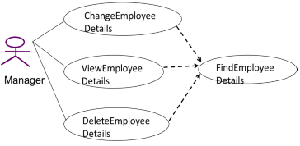

What is the type of the relationship between ChangeEmployeeDetails and FindEmployeeDetails Use Cases?

1. Generalization
2. Include
3. Extend
4. Association

ANSWER:B

Consider the following statements related to Class diagrams.

(i) Class diagrams are used for a wide variety of purposes, including both conceptual/domain modeling and detailed design modeling.

(ii) Multiplicity is used to denote the number of instances of a class involved in a relationship.

(iii) Composition in a relationship is represented by a hollow diamond and a line between classes.

Which of the following is true about the above statements?

1. Only (i)
2. Only (ii)
3. Only (i) and (ii)
4. All

ANSWER:C

Consider the following statements related to Object Oriented Design and modeling?

(i) High coupling and low cohesion are two very important goals of Object Oriented Design.

(ii) Object oriented developers look for the same reuse opportunities through the use of design patterns.

(iii) The goal of a pattern is not to discover or invent a new solution to a problem, but to formally structure an existing solution to a common problem so that others may use it and take

advantage of it.

Which of the above statement(s) is/are correct?

1. Only (i)
2. Only (ii) and (iii)
3. Only (i) and (ii)
4. All

ANSWER:B

Consider the following statements related to diagrams in UML2.0.

(i) In an activity diagram, a swimlane is a segment that shows the activities performed by a particular role.

(ii) The focus of control in an Activity diagram is a small rectangle that will let one know which object has control at a particular point in time.

(iii) An Activity diagram is appropriate for modelling business processes.

Which of the above statement(s) is/are correct?

1. Only (i)
2. Only (ii) and (iii)
3. Only (i) and (iii)
4. All

ANSWER:C

A set of objects that share the same ___________ is referred to as a class.

1. attributes
2. message
3. behavior
4. attributes and behaviours

ANSWER:D

The UML ___________ diagrams are used to model the static view of a system.

1. activity
2. class
3. sequence
4. communication

ANSWER:B

In object oriented analysis and design ___________ is the concept that different objects can respond to

the same message in different ways.

1. Polymorphism
2. Generalization
3. Encapsulation
4. Specialization

ANSWER:A

The UML __________ diagrams are used to model the dynamic view of a system.

1. deployment
2. component
3. state
4. communication

ANSWER:C

Which of the following is/are not UML diagrams?

1. Composite Structure Diagram
2. Communication Diagram
3. Entity Relationship Diagram
4. Profile Diagram

ANSWER:C

Consider the following statements with regard to object and class diagrams.

(i) An object diagram is a diagram that shows objects and their relationships at a point in time.

(ii) An association class in a class diagram is an association that is also a class.

(iii) The class diagram shows a collection of classes, interfaces, associations, collaborations and constraints.

Which of the above statements is/are correct?

1. Only (i)
2. Only (ii) and (iii)
3. Only (i) and (iii)
4. All

ANSWER:D

Consider the following statements related to OOAD.

1. Objects work together by sending messages to one another. The messages are requests to perform operations.
2. Objects are typically associated with one another. The association can take a variety of forms. An object in one class may associate with any number of objects in another class.
3. Polymorphism means "many forms." Applied to object-oriented techniques, it means that the same named behaviour may be completed differently for different object classes.

Which of the above statements is/are correct?

1. Only (i)
2. Only (ii) and (iii)
3. Only (i) and (iii)
4. All

ANSWER:D

Which type of class relationship can be described as "kind of" or "is a"?

1. generalization/specialization
2. association
3. aggregation
4. multiplicity

ANSWER:A

What specifies the number of objects that can participate in a relationship at any point of time?

1. generalization/specialization
2. association
3. aggregation
4. multiplicity

ANSWER:D

Consider the following diagram.

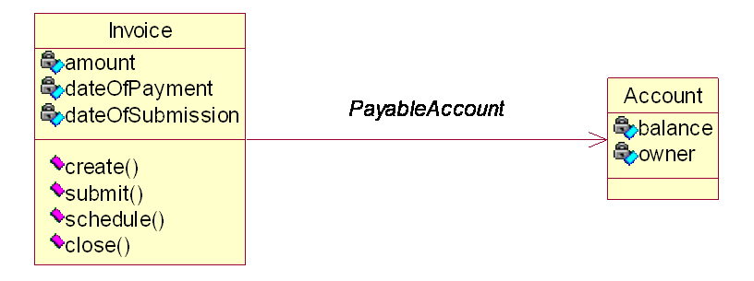

The arrow in the above diagram indicate,

1. refer to
2. association
3. dependency
4. Navigability

ANSWER:D

Consider the following UML diagram.

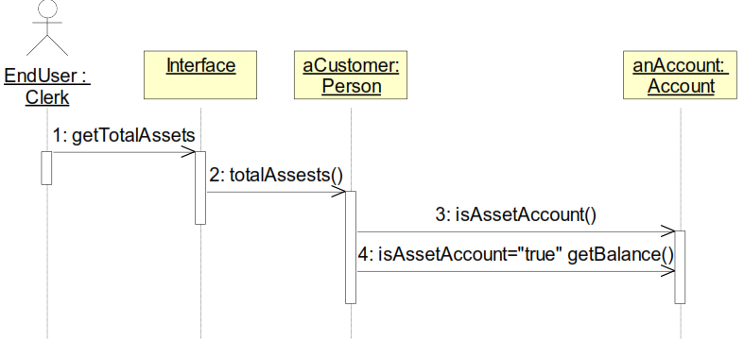

1. Person is asked for assets, sums the balance of each asset Account
2. Customer is asked for assets, returns the balance of asset account.
3. It is a Communication diagram.
4. isAssetAccount method must be implemented by the Person class

ANSWER:A

Consider the following statements.

(i) Lifelines in a sequence diagram may have activations to indicate when the life line has focus of control.

(ii) It consists of different states and transitions between states for different objects of a scenario.

(iii) Time is represented in a sequence diagram as proceeding in the downward direction.

Which of the above is/are true for a sequence diagram?

1. Only (i)
2. Only (ii) and (iii)
3. Only (i) and (iii)
4. All

ANSWER:C

Consider the following use case diagram drawn for a particular scenario.

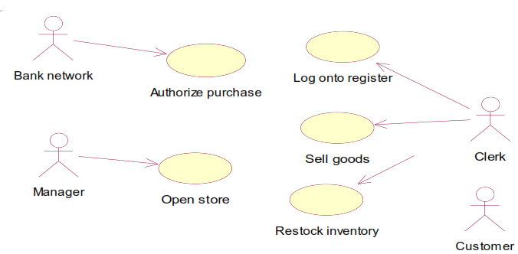

What are the system actors in the given Use Case diagram?

1. Clerk, Manager, Customer
2. Clerk, Manager, Bank network
3. Clerk, Manager, Bank network, Customer
4. Manager, Bank network, Customer

ANSWER:C

Some questions related to UML diagrams with possible answers are given below.

(i). q. List three diagrams that give a dynamic view of a system?

a. sequence, component, state

(ii). q. Is a use case the same as a scenario?

a. Yes.

(iii). q. What does multiplicity indicates in a class diagram?

a. The number of objects in one class that relate to one object of an associated class.

Which of the above pairs is/are correct?

1. Only (iii)
2. Only (ii) and (iii)
3. Only (i) and (iii)
4. All

ANSWER:A

Consider the following use case diagram

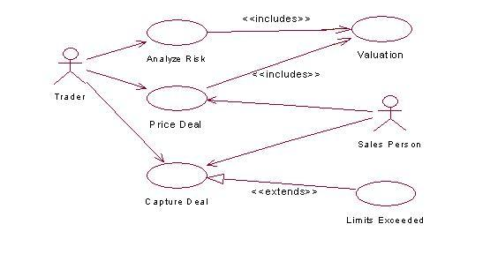

The following are three statements based on the use case diagram given above,

(i) The trader and the sales person do not play the same role in the system.

(ii) Both Analyze Risk and Prize Deal are required to value the deal.

(iii) There may not be customers with exceeded limits.

Which of the following is true about the above statements?

1. Only (iii)
2. Only (ii) and (iii)
3. Only (i) and (iii)
4. All

ANSWER:D

Consider the following statements with respect to Use case modeling.

(i) An automatic system backup that runs every evening can be represented by a Time actor.

(ii) Credit bureau authorizing the charging by a credit card is an example for an external server actor.

(iii) Warehouse receiving a package order to prepare a shipment is an example for an external

receiver actor if the warehouse is outside the scope of the system.

Which of the following is true about the above statements?

1. Only (iii)
2. Only (ii) and (iii)
3. Only (i) and (iii)
4. All

ANSWER:D

Which of the following statements is/are correct regarding Activity diagrams?

1. In UML, an activity diagram is used to display the sequence of activities.
2. They may be used to detail situations where parallel processing may occur in the execution of some activities.
3. An Activity diagram can contain generalization relationships.
4. A and B.

ANSWER:D

Which of the given statements is/are correct with respect to the following UML diagram?

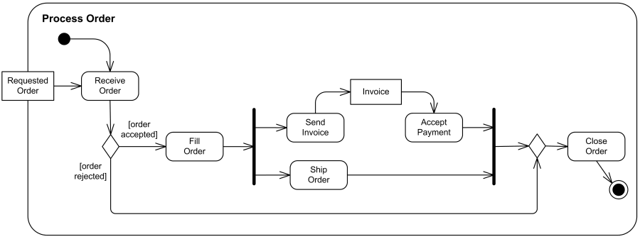

1. It is a Interaction Overview diagram.
2. Send Invoice and Ship Order are parallel activities.
3. Process order is a swimlane.
4. Send Invoice, Fill Order and Ship Order are parallel activities.

ANSWER:A

A Class in a problem domain has attributes, behaviour and sometimes can be in different states. In a

University Registration system, the “Course” identified as an *Entity* Class in the problem domain.

From the following, identify the statement which represents object of the Class, an attribute,

behaviour and a state of the class respectively.

1. IT3002, expired, NoOfUnits, AddStudent
2. IT 2103, NoOfUnits, AddStudent, expired
3. NoOfUnits, IT 1104, AddStudent, expired
4. NoOfUnits , expired, IT 2104, AddStudent

ANSWER:B

Consider the following statements related to state diagrams in UML2.0.

(i) A state can have a transition that returns to itself. This is most useful when an effect is associated

with the transition.

(ii) They are most commonly used to model the static behavior of classes.

(iii) Guard condition is a Boolean expression that must be true before the transition occurs and they

are shown in square brackets.

Which of the above statement(s) is/are correct?

1. Only (iii)
2. Only (ii) and (iii)
3. Only (i) and (iii)
4. All

ANSWER:C

Identify the following notations used in UML 2.0 Activity Diagrams.

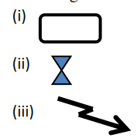

1. (i) – Activity (ii) –Decision Node (iii) – Transition
2. (i) – State (ii) –Decision Node (iii) – Interruption Activity
3. (i) – Activity (ii) –Passage of time (iii) – Interruption Activity
4. (i) – Activity (ii) –Decision Node (iii) – Interruption Activity

ANSWER:C

Consider the following multiplicity indicators and their meanings.

Indicator Meaning

(i) * Zero or More

(ii) 1..* One or More

(iii) 0..1 Zero or One

(iv) 4..7,9 4,5,6,7 or 9

(v) 1-2 1 or 2

Which of the above is/are correct?

1. (i), (ii) and (iii) only
2. (ii) and (iii) only
3. (i),(ii),(iii) and (iv) only
4. All

ANSWER:C